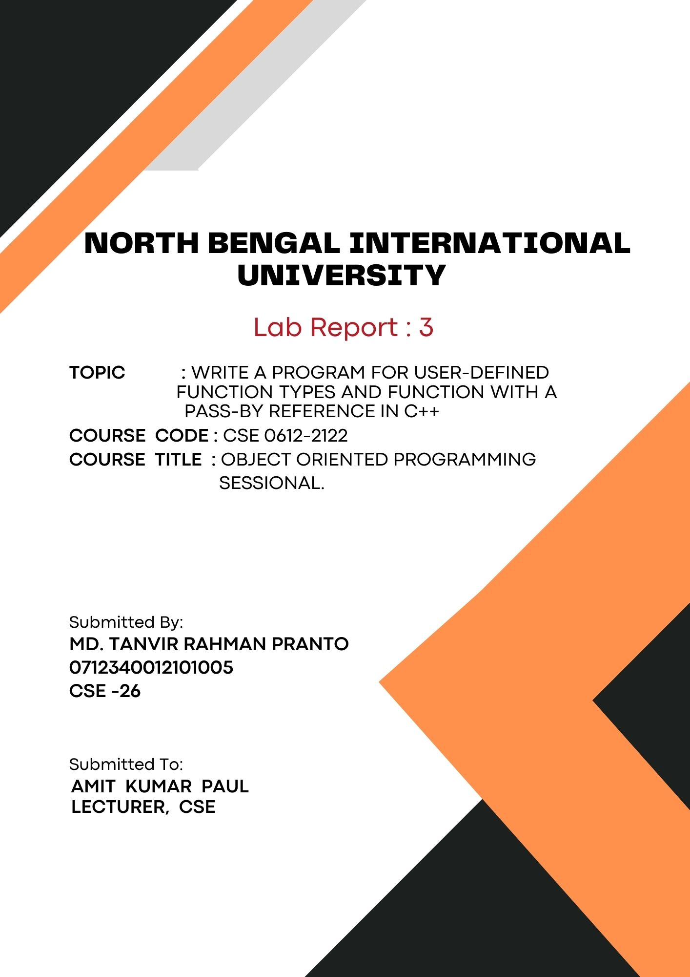
1

• WRITE A PROGRAM FOR USER-DEFINED FUNCTION TYPES AND FUNCTION WITH A PASS-BY REFERENCE IN C++:

# program to passed argument with a return value in C++ :
Code:
#include <iostream>

int square(int num) {
return num * num;
}

int main() {
int number;

std::cout << "Enter a number: ";
std::cin >> number;

int result = square(number);

std::cout << "The square of " << number << " is " << result << std::endl;

return 0;
}

Output:
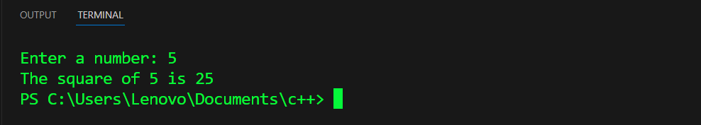

# program to passed no argument with a no return value in C++ :
Code:
#include <iostream>

void greet() {
std::cout << "Hello! Welcome to the C++ world!" << std::endl;
}

int main() {

greet();

return 0;
}

Output:
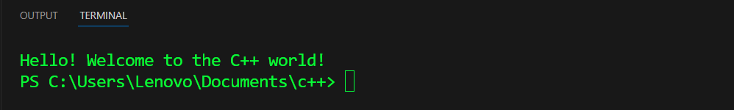

# program to passed no argument but with a return value in C++:
Code:
#include <iostream>
#include <ctime>

int getCurrentYear() {
time_t now = time(0);
tm *ltm = localtime(&now);
return 1900 + ltm->tm_year;
}

int main() {

int currentYear = getCurrentYear();

std::cout << "The current year is: " << currentYear << std::endl;

return 0;
}

Output:
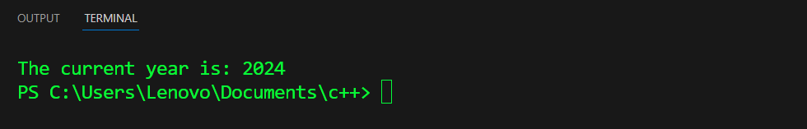

# program to passed argument but no return value in C++:
Code:
#include <iostream>

// Function that takes two integers as arguments and prints their sum
void printSum(int a, int b) {
int sum = a + b;
std::cout << "The sum of " << a << " and " << b << " is " << sum << std::endl;
}

int main() {
int num1, num2;
std::cout << "Enter the first number: ";
std::cin >> num1;

std::cout << "Enter the second number: ";
std::cin >> num2;

printSum(num1, num2);

return 0;
}

Output:
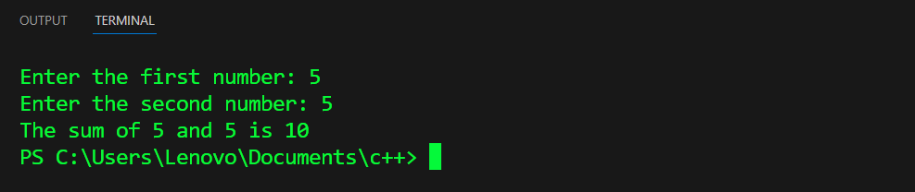

# Program to pass by Reference:
Code:
#include <iostream>

void swap(int &a, int &b) {
int temp = a;
a = b;
b = temp;
}
int main() {
int num1, num2;

std::cout << "Enter the first number: ";
std::cin >> num1;

std::cout << "Enter the second number: ";
std::cin >> num2;

std::cout << "Before swapping: num1 = " << num1 << ", num2 = " << num2 << std::endl;

swap(num1, num2);

std::cout << "After swapping: num1 = " << num1 << ", num2 = " << num2 << std::endl;

return 0;
}

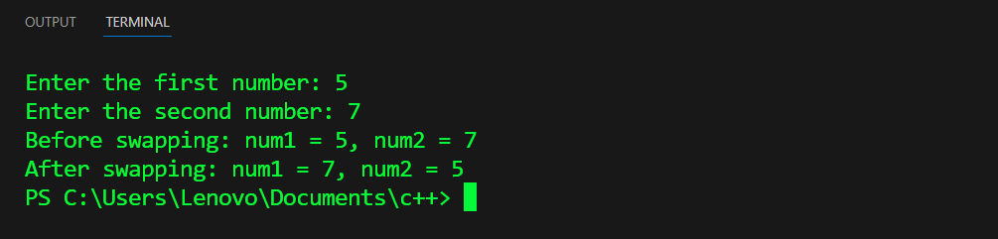
Output:

